Metta Saketh Srinivasa Rao

CS 575

[mettas@oregonstate.edu](mailto:mettas@oregonstate.edu)

What your own-choice quantity was and how it fits into the simulation.

The quantity I chose was to introduce Tigers into the simulation. The tigers feed on the deer. Each deer can feed 3 tigers at the same time. So, if the number of deer is less than 1/3rd of the tigers, then the number of tigers will decrease. If the number of deer is more than the number of deer, then the deer decrease by one and the tigers increase by one. If the deer is more than 0 but lass than 1/3rd of the tigers, then the tigers decrease by one and lastly, if deer = 0, then tigers will also be equal to zero.

A table showing values for temperature, precipitation, number of deer, height of the grain, and your own-choice quantity as a function of month number.

|  |  |  |  |  |  |
| --- | --- | --- | --- | --- | --- |
| **Date** | **Sum of Temperature** | **Sum of Number of Deer** | **Sum of Number of Tigers** | **Sum of Precipitation** | **Sum of Grain Height** |
| 2024-01 | 60 | 4 | 6 | 7 | 5 |
| 2024-02 | 47.49 | 0 | 0 | 8.13 | 7.03 |
| 2024-03 | 51.52 | 2 | 3 | 12.44 | 22.26 |
| 2024-04 | 63.06 | 5 | 6 | 11.59 | 18.32 |
| 2024-05 | 61.88 | 7 | 7 | 13.87 | 7.46 |
| 2024-06 | 69.7 | 6 | 10 | 11.46 | 0 |
| 2024-07 | 78.87 | 3 | 12 | 9.07 | 0 |
| 2024-08 | 76.61 | 1 | 10 | 5.5 | 0 |
| 2024-09 | 83.19 | 0 | 0 | 4.42 | 0 |
| 2024-10 | 67.89 | 0 | 0 | 2.07 | 0 |
| 2024-11 | 47.66 | 0 | 1 | 1.63 | 3.33 |
| 2024-12 | 36.18 | 2 | 4 | 1.73 | 8.88 |
| 2025-01 | 33.43 | 6 | 18 | 6.66 | 8.2 |
| 2025-02 | 33.82 | 8 | 21 | 8.16 | 7.96 |
| 2025-03 | 38.45 | 7 | 23 | 9.68 | 12.58 |
| 2025-04 | 64.8 | 9 | 26 | 11.67 | 12.01 |
| 2025-05 | 65.44 | 0 | 1 | 14.15 | 0.94 |
| 2025-06 | 76.39 | 0 | 1 | 10.43 | 0.99 |
| 2025-07 | 82.07 | 0 | 0 | 8.65 | 0.99 |
| 2025-08 | 79.19 | 0 | 2 | 7.34 | 0.99 |
| 2025-09 | 69.99 | 0 | 0 | 3.84 | 0.99 |
| 2025-10 | 65.71 | 1 | 1 | 2.28 | 0.02 |
| 2025-11 | 52.83 | 1 | 0 | 2.77 | 1.31 |
| 2025-12 | 41.52 | 2 | 4 | 2.17 | 1.43 |
| 2026-01 | 46.84 | 2 | 5 | 7.12 | 11.13 |
| 2026-02 | 32.08 | 6 | 23 | 10.35 | 5.98 |
| 2026-03 | 46.38 | 7 | 20 | 9.59 | 9.15 |
| 2026-04 | 48.67 | 9 | 22 | 13.45 | 5.15 |
| 2026-05 | 72.98 | 5 | 17 | 12.19 | 5.7 |
| 2026-06 | 65.43 | 2 | 16 | 9.32 | 0 |
| 2026-07 | 78.47 | 0 | 14 | 6.81 | 0 |
| 2026-08 | 74.08 | 0 | 1 | 7.33 | 0 |
| 2026-09 | 82.19 | 0 | 1 | 4.16 | 0 |
| 2026-10 | 60.51 | 0 | 0 | 1.36 | 0 |
| 2026-11 | 52.33 | 1 | 1 | 2.25 | 1.98 |
| 2026-12 | 46.11 | 3 | 5 | 3.43 | 3.3 |
| 2027-01 | 41.31 | 5 | 6 | 3.6 | 9.5 |
| 2027-02 | 39.43 | 8 | 25 | 10.28 | 20.32 |
| 2027-03 | 54.47 | 13 | 28 | 12.13 | 5.05 |
| 2027-04 | 50.51 | 2 | 2 | 13.75 | 4.13 |
| 2027-05 | 67.98 | 5 | 6 | 12.21 | 1.5 |
| 2027-06 | 77.9 | 4 | 7 | 9.91 | 0 |
| 2027-07 | 78.12 | 2 | 9 | 10.07 | 0 |
| 2027-08 | 85.9 | 0 | 0 | 4.77 | 0 |
| 2027-09 | 68.72 | 0 | 3 | 4.33 | 0 |
| 2027-10 | 62.18 | 0 | 3 | 1.95 | 0.05 |
| 2027-11 | 63.95 | 0 | 1 | 1.56 | 0.16 |
| 2027-12 | 49 | 0 | 3 | 4.19 | 3.99 |
| 2028-01 | 39.47 | 4 | 14 | 7.14 | 3.93 |
| 2028-02 | 38.65 | 7 | 16 | 9.81 | 28.79 |
| 2028-03 | 49.54 | 9 | 18 | 12.89 | 28.01 |
| 2028-04 | 54.47 | 12 | 21 | 11.66 | 12.89 |
| 2028-05 | 74.18 | 0 | 1 | 14.48 | 1.87 |
| 2028-06 | 67.1 | 0 | 0 | 12.77 | 0 |
| 2028-07 | 82.14 | 0 | 2 | 8.28 | 0.01 |
| 2028-08 | 81.71 | 0 | 1 | 4.57 | 0.01 |
| 2028-09 | 79.86 | 0 | 3 | 1.99 | 0.01 |
| 2028-10 | 64.12 | 0 | 3 | 0.11 | 0.01 |
| 2028-11 | 48.57 | 0 | 0 | 0.31 | 2.27 |
| 2028-12 | 46.99 | 2 | 2 | 2.42 | 7.67 |
| 2029-01 | 34.07 | 4 | 14 | 7.07 | 5.77 |
| 2029-02 | 32.74 | 7 | 17 | 7.06 | 17.53 |
| 2029-03 | 45.77 | 10 | 19 | 12.28 | 13.37 |
| 2029-04 | 64.52 | 11 | 21 | 14.54 | 0 |
| 2029-05 | 68.87 | 0 | 2 | 12.33 | 0.41 |
| 2029-06 | 79.14 | 0 | 1 | 10.72 | 0.42 |
| 2029-07 | 75.2 | 0 | 3 | 7.48 | 0.42 |
| 2029-08 | 81.01 | 0 | 1 | 4.42 | 0.42 |
| 2029-09 | 67.19 | 0 | 0 | 3.69 | 0.42 |
| 2029-10 | 57.69 | 0 | 3 | 2.38 | 0.73 |
| 2029-11 | 48.11 | 1 | 2 | 2.18 | 4.4 |
| 2029-12 | 37.35 | 4 | 5 | 4.56 | 11.47 |

graph showing temperature, precipitation, number of deer, height of the grain, and your own-choice quantity as a function of month number.

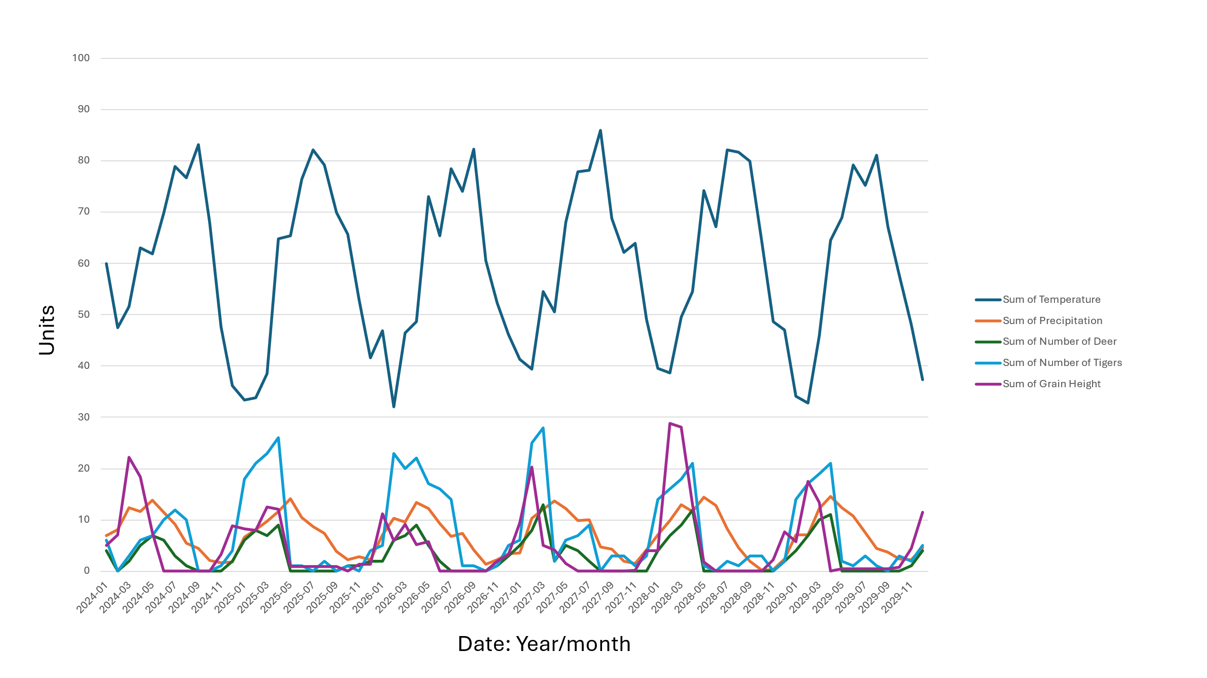

From the above graph we can see that the temperature fluctuates between 30 and 85 degrees Fahrenheit. As for the precipitation fluctuates between 0 and 12 inches. These two are independent of the other factors and are not affected by any other quantities. Now for the grain, we can see that the grain increases as the precipitation increases and the grain decreases as the number of deer increases. Because the precipitation causes the grain production to increase and deer eat the grain which causes the grain height to decrease. No, the number of tigers increases as the deer increase and number of deer decreases as the tigers increase, as these to have a very high influence on each other. Deer increases causes the tiger population to increase and then these tigers eat the deer and this causes the deer to die. From the graph we can see that as the grain increases the deers increase and due to this the number of tigers increase as well, but when the tiger’s increase the deer’s decrease and this causes the grain to increase as the deer that eat the grain decreases.